Name:___________________________________________________Period:______Score: ____
54

Questions for thought: Please answer these in at least THREE complete sentences and use page numbers or a direct quote to support your claims. Be prepared to discuss your answers with a partner and/or the entire class. (+3 points each – 12 points total)

- Why was Moishe the Beadle important to Elie Wiesel?

- Summarize the story Moishe the Beadle told on his return from being deported. Why did he say he had returned to Sighet?

- Describe, in order, the events that happened from the last day of Passover until Shavuot.

- What can you say about Wiesel’s feelings about the Hungarian police?

Vocabulary: Please complete the chart below for the following words. Page numbers are given after each word. If you do not know the meaning of the word, look it up and write the definition. These are words you will encounter as we read this section, and you will need to know their meaning. (10 points)

Key Terms and page #’s | I know it! | I think I know it… | Definition | Now, I know it!
Hasidic, 3
penury, 3
Kabbalists, 4
divinity, 5
deportees, 6
annihilate, 8
emigration, 8
liquidate, 9
Fascist, 9
billeted, 9
jubilant, 10
sublime, 10
Passover, 10
edicts, 10
delusion, 12
Shavuot, 12
anecdotes, 12
Gestapo, 13
liquidated, 13
phylacteries, 16
surreptitiously, 16
oppressors, 19
conflagration, 21

Please complete the following critique for this section of Night. (19 points)

When reading section 1 of Night, the three parts that affected me the most were _____________________________________, ____________________________________, _____________________________________.
The first part stood out because _________________________________________
__________________________________________________________________________________________________________________________________________________________.
A line that best exemplifies this is on page _______ and reads, “__________________________
_________________________________________________________________________________________________________________________________________________________.” I chose this part because it made me think/feel ________________________________________
___________________________________________________ because ___________________
_____________________________________________________________________________.
The second part stood out because _________________________________________
__________________________________________________________________________________________________________________________________________________________.
A line that best exemplifies this is on page _______ and reads, “__________________________
_________________________________________________________________________________________________________________________________________________________.”I chose this part because it made me think/feel ________________________________________
___________________________________________________ because ___________________
_____________________________________________________________________________.
The third part stood out because _________________________________________
__________________________________________________________________________________________________________________________________________________________.
A line that best exemplifies this is on page _______ and reads, “__________________________
_________________________________________________________________________________________________________________________________________________________.” I chose this part because it made me think/feel ________________________________________
___________________________________________________ because ___________________
_____________________________________________________________________________.
Overall, I find this section (disturbing, thought provoking, interesting). I believe that
_______________________________________________________________________________________________________________________________________________________________________________________________________________________________________.
In preparation for your I-Search and/or to add to the I-Search Wall, what are three questions you have at the end of this section? (3 points)

1.
2.
3.

(10 points) List at least 5 facts. List a total of at least five items in the other two sections.
Important Facts Questions/Wonderings

Unfamiliar words/terms

These will be part of your notebook grade and placed in the Literary Analysis section of your notebook.

Section 1: Do Now’s
These will be placed in student’s notebooks and stamped daily when completed.

Day 1

Respond to the following statement in a minimum of five lines:
What do you know about the Holocaust?

When complete, you will be asked to read your response to your shoulder partner and discuss how your answers are similar and/or different.

Day 2

Respond to the following statement in a minimum of five lines:
Why do you think Moishe the Beadle was not believed?

Day 3
Respond to the following statement in a minimum of five lines:
What stands out most for you about the scene when the Hungarians made the Jews run from their ghetto to the smaller ghetto?

Day 4
Respond to the following statement in a minimum of five lines:
Look at the picture of the cattle car. Imagine you and 79 others being forced to cram yourselves into this car and being deported from your home to a place unknown by men with weapons. What might you be thinking/feeling at this moment?

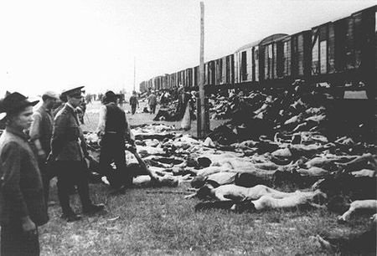
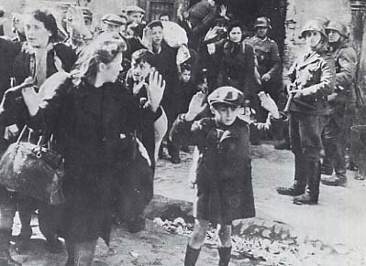
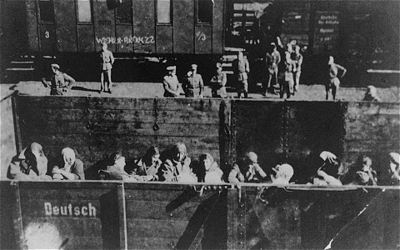
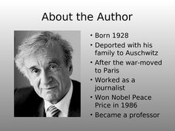
Of his family of six, only Elie and his two older sisters survived the Holocaust.

Wiesel moved the New York in 1955 and became a US citizen in 1963.

He taught at Boston University, City University of New York, and Yale.

Elie Wiesel died on July 2, 2016 in New York City at the age of 87.

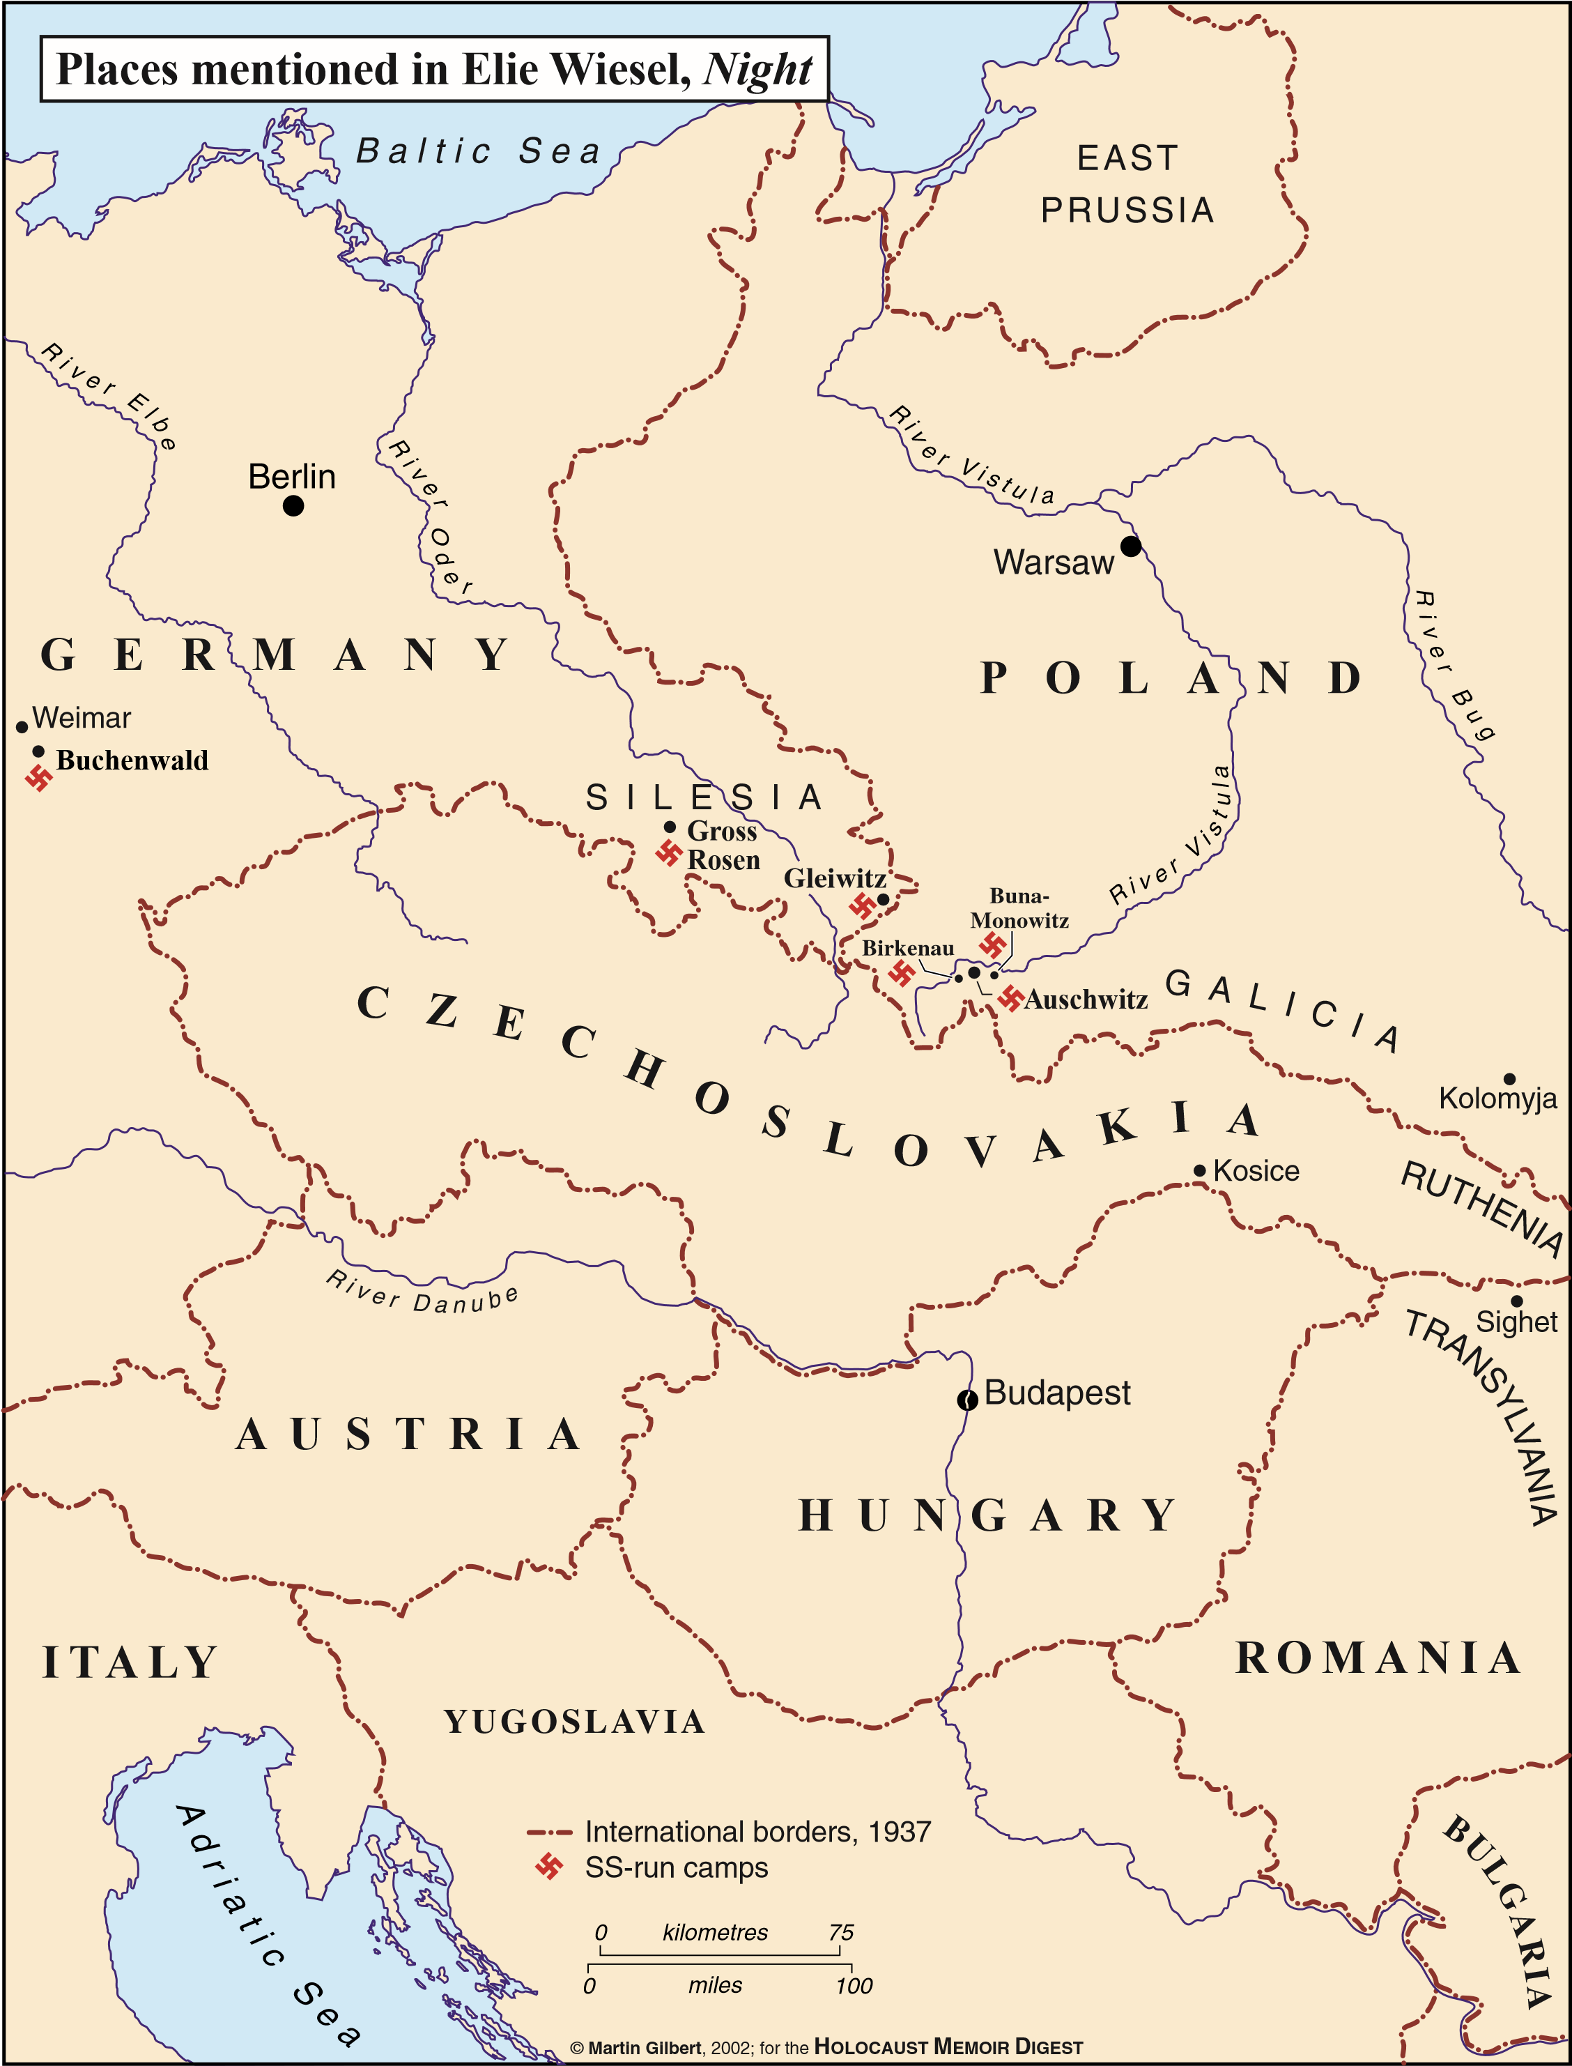

While the color of the star the Jewish people were forced to wear was yellow, others who were arrested and persecuted had to wear different colored stars. The color-coding allowed the Nazis to easily discern why people had been detained.
Red Green Blue Purple Pink Black