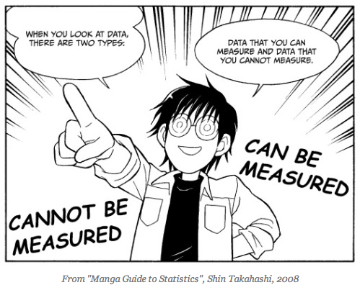
To locate your Statistical Study use the following website:
http://www.sciencedaily.com/

- Copy and paste the questions and answers listed below to your word document. If you are unable to find the answers to these questions using your study, you must find another study!

- Copy and paste your article to a word document.

- Make sure your article has a picture and title.

Use your article to answer the following questions:

- Does your article just relay the facts of the study or does it make generalizations and/or predictions?

- Who or what is being studied?

- How many people or physical objects were studied?

- How did they measure what was being studied (i.e. global warming could be measured by temperature)?

- How did they collect their data?

